Build an EMA-based Signal Strategy
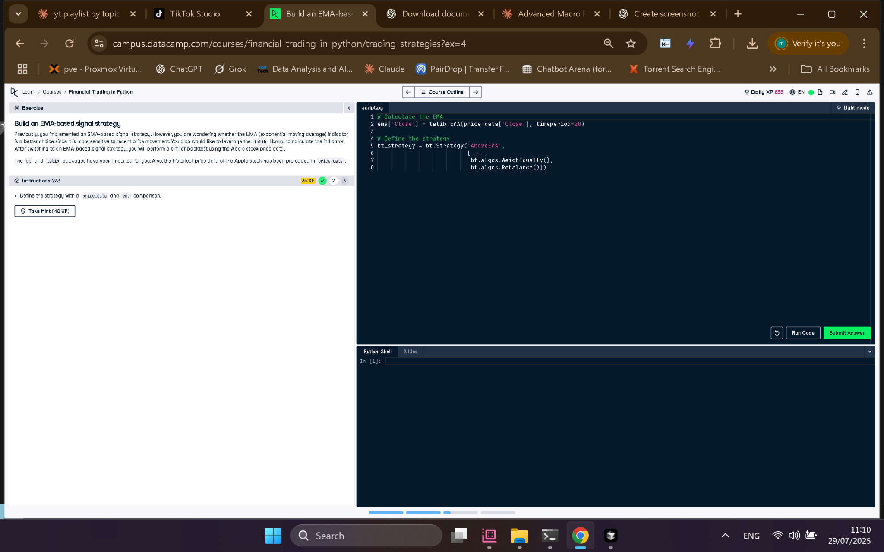

Full Python Code
# Calculate the EMA
ema['Close'] = talib.EMA(price_data['Close'], timeperiod=20)
# Define the strategy
bt_strategy = bt.Strategy('AboveEMA',
[bt.algos.SelectWhere(price_data > ema),
bt.algos.WeighEqually(),
bt.algos.Rebalance()])

Explanation in Simple Words
This code builds a trading strategy using the EMA. First, it calculates the 20-day EMA for the stock's closing price. Then, it defines a strategy that selects stocks where the price is above the EMA, assigns equal weights to them, and rebalances the portfolio. This helps identify upward momentum.

